Q1.

Code:

|  |
| --- |
| ***package Q1;***  ***import javax.swing.*;  public class GreetingFrame {  public static void main(String[] args) {    JFrame frame = new JFrame("Hello Java");     frame.setSize(800, 600);     frame.setDefaultCloseOperation(JFrame.EXIT_ON_CLOSE);     frame.setVisible(true);  } }*** |

Output:

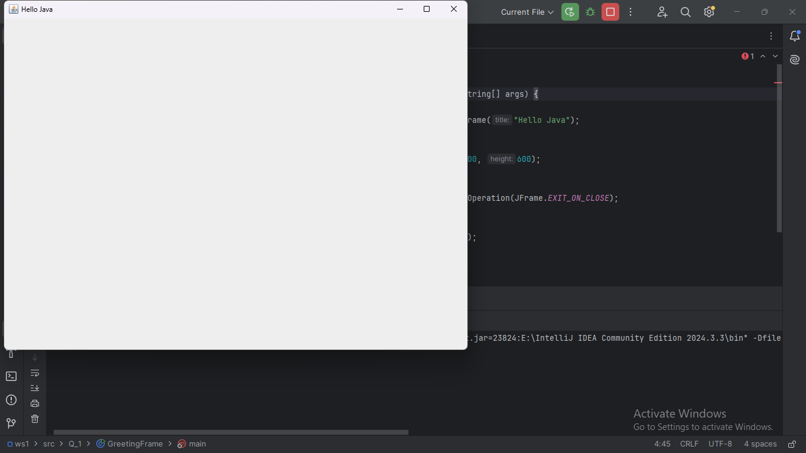

Q2

Code:

Output:

|  |
| --- |
| ***package Q2; import javax.swing.*; import java.util.Scanner;  public class UserInfo {  public static void main(String[] args) {    Scanner inputScanner = new Scanner(System.in);  System.out.print("Enter your given name: ");  String givenName = inputScanner.nextLine();   System.out.print("Enter your surname: ");  String surname = inputScanner.nextLine();  String completeName = givenName + " " + surname;   inputScanner.close();   SwingUtilities.invokeLater(() -> {    JFrame userFrame = new JFrame(completeName);     userFrame.setSize(400, 300);   userFrame.setDefaultCloseOperation(JFrame.EXIT_ON_CLOSE);     userFrame.setVisible(true);  });  } }*** |

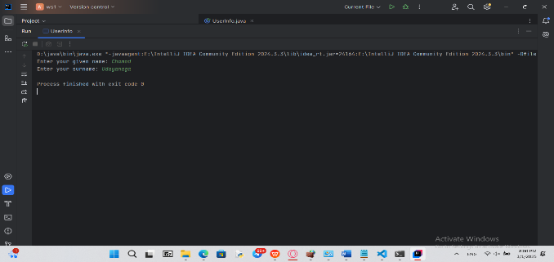

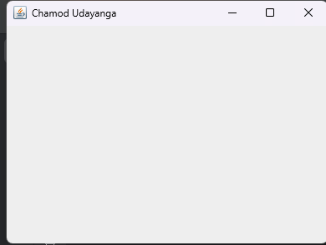

Q3 Code:

|  |
| --- |
| ***package Q3;  import java.util.Scanner;  public class UserNameInitials {  public static void main(String[] args) {    Scanner inputScanner = new Scanner(System.in);     System.out.print("Enter your given name: ");  String givenName = inputScanner.nextLine();   System.out.print("Enter your middle name: ");  String middleName = inputScanner.nextLine();   System.out.print("Enter your surname: ");  String surname = inputScanner.nextLine();     String middleInitial = middleName.charAt(0) + ".";     System.out.println("Formatted Name: " + givenName + " " + middleInitial + " " + surname);     inputScanner.close();  } }*** |

Output

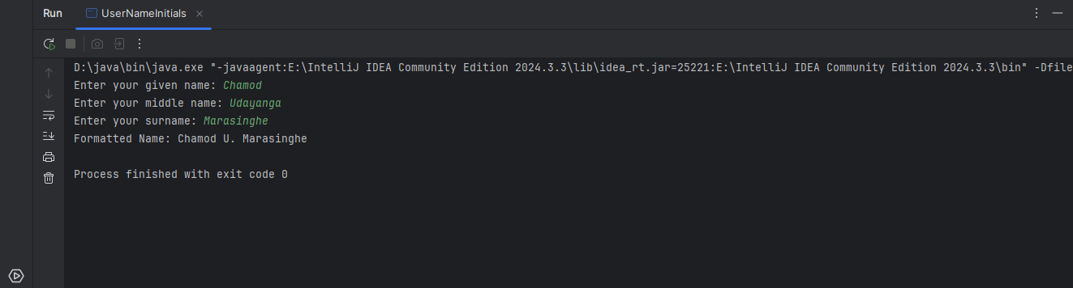

Q4 Code:

|  |
| --- |
| ***package Q4;  import java.time.LocalDate; import java.time.format.DateTimeFormatter;  public class CurrentDate {  public static void main(String[] args) {    LocalDate currentDate = LocalDate.now();     DateTimeFormatter dateFormatter = DateTimeFormatter.ofPattern("d MMM yyyy");     String formattedCurrentDate = currentDate.format(dateFormatter);     System.out.println("Current Date: " + formattedCurrentDate);  } }*** |

Output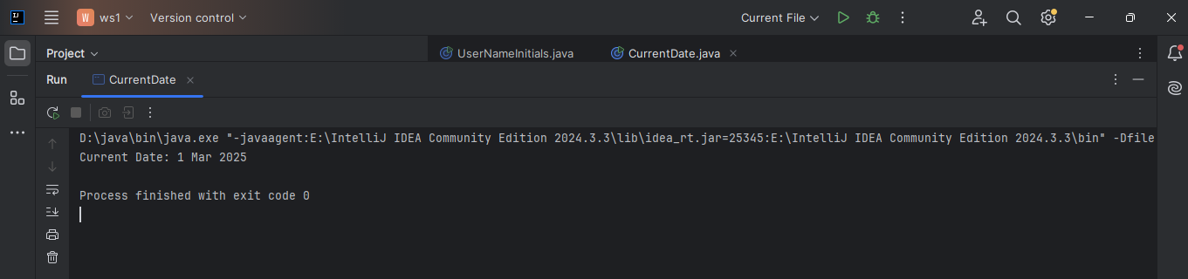

Q5 Code:

|  |
| --- |
| ***package Q5;  import java.time.LocalDate; import java.time.format.DateTimeFormatter; import java.util.Locale;  public class CurrentDayDate {  public static void main(String[] args) {    LocalDate currentDate = LocalDate.now();     DateTimeFormatter dateFormatter = DateTimeFormatter.ofPattern("EEEE, MMMM d, yyyy", Locale.ENGLISH);     String formattedCurrentDate = currentDate.format(dateFormatter);  System.out.println(formattedCurrentDate);  } }*** |

Output: 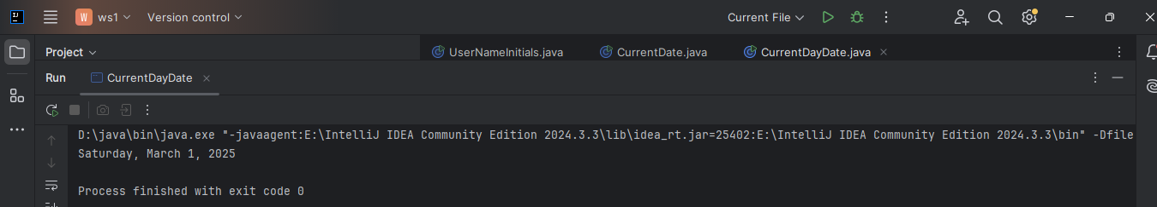

Q6 Code:

|  |
| --- |
| ***package Q6;  import javax.swing.*; import java.util.Scanner;  public class WindowCreator {  public static void main(String[] args) {    Scanner inputScanner = new Scanner(System.in);     System.out.print("Enter the window title: ");  String windowTitle = inputScanner.nextLine();   System.out.print("Enter the width of the window: ");  int windowWidth = inputScanner.nextInt();   System.out.print("Enter the height of the window: ");  int windowHeight = inputScanner.nextInt();     inputScanner.close();     JFrame windowFrame = new JFrame(windowTitle);  windowFrame.setSize(windowWidth, windowHeight);  windowFrame.setDefaultCloseOperation(JFrame.EXIT_ON_CLOSE);  windowFrame.setVisible(true);  } }*** |

Output:

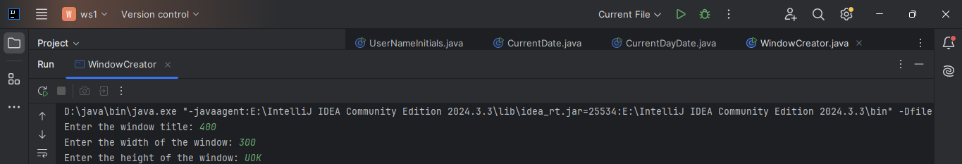

Q7 Code:

|  |
| --- |
| ***import javax.swing.*; import java.text.SimpleDateFormat; import java.util.Date; import java.util.Timer; import java.util.TimerTask;  public class TimeDisplayWindow {  public static void main(String[] args) {    JFrame timeWindow = new JFrame();  timeWindow.setSize(400, 200);  timeWindow.setDefaultCloseOperation(JFrame.EXIT_ON_CLOSE);  timeWindow.setVisible(true);     Timer timeUpdater = new Timer(true);  timeUpdater.scheduleAtFixedRate(new TimerTask() {  @Override  public void run() {    String formattedTime = new SimpleDateFormat("hh:mm:ss a").format(new Date());  timeWindow.setTitle(formattedTime);  }  }, 0, 1000); // Update every second  } }*** |

Output: 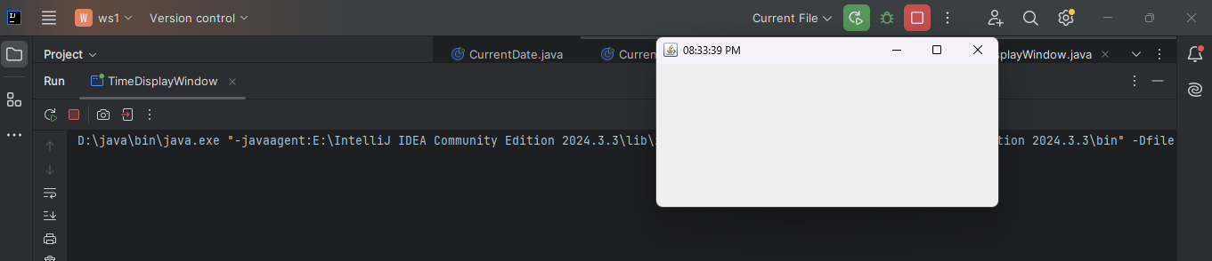

Q8 Code:

|  |
| --- |
| ***package Q8; import java.util.Scanner;  public class StringSplitter {  public static void main(String[] args) {    Scanner userInputScanner = new Scanner(System.in);     System.out.print("Enter a string containing a single exclamation mark (!): ");  String userInput = userInputScanner.nextLine();     userInputScanner.close();     int exclamationIndex = userInput.indexOf('!');     if (exclamationIndex == -1 || userInput.indexOf('!', exclamationIndex + 1) != -1) {  System.out.println("Error: The input must contain exactly one exclamation mark.");  return;  }     String substringBefore = userInput.substring(0, exclamationIndex).trim();  String substringAfter = userInput.substring(exclamationIndex + 1).trim();    System.out.println(substringBefore);  System.out.println(substringAfter);  } }*** |

Output:

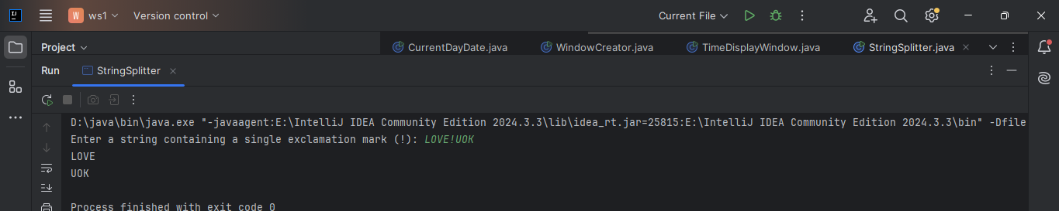

Q9 Code:

|  |
| --- |
| ***package Q9;  import java.util.Scanner;  public class StringInfo {  public static void main(String[] args) {     Scanner inputScanner = new Scanner(System.in);    System.out.print("Enter a string: ");  String userInput = inputScanner.nextLine();     inputScanner.close();     int stringLength = userInput.length();     if (stringLength > 0) {  char firstCharacter = userInput.charAt(0);  char lastCharacter = userInput.charAt(stringLength - 1);   // Display output  System.out.println(stringLength);  System.out.println(firstCharacter);  System.out.println(lastCharacter);  } else {  System.out.println("Error: Empty string entered.");  }  } }*** |

Output:

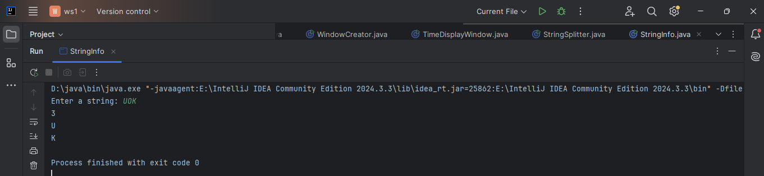

Q10 Code:

|  |
| --- |
| ***package Q10; import java.util.Scanner;  public class OddLengthWord {  public static void main(String[] args) {  // Create Scanner object  Scanner inputScanner = new Scanner(System.in);   // Prompt user for input  System.out.print("Enter an odd-length word: ");  String userInput = inputScanner.nextLine();   // Close the scanner  inputScanner.close();   // Get the length of the word  int wordLength = userInput.length();   // Check if the word has an odd length  if (wordLength % 2 == 1) {  int middleIndex = wordLength / 2; // Calculate middle index  char middleCharacter = userInput.charAt(middleIndex); // Get middle character   // Display output  System.out.println("Middle character: " + middleCharacter);  } else {  System.out.println("Error: The word must have an odd number of characters.");  }  } }*** |

Output:

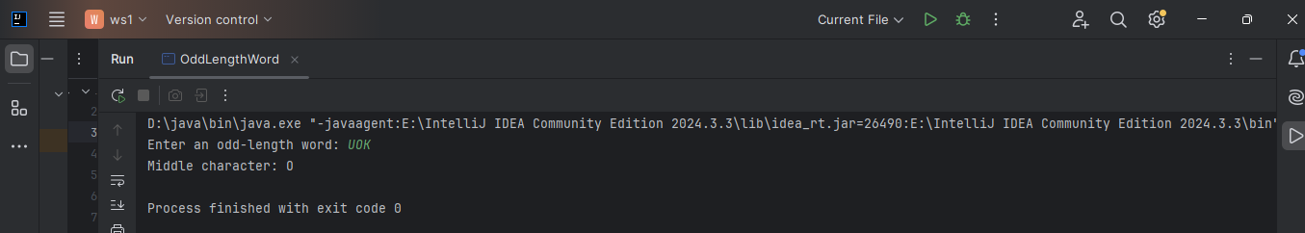

Q11 Code:

|  |
| --- |
| ***package Q11;***  ***import java.util.Scanner;  public class uDAYAFullNameFormatter {  public static void main(String[] args) {    Scanner userInputScanner = new Scanner(System.in);     System.out.print("Enter your full name (First Middle Last): ");  String completeName = userInputScanner.nextLine();     userInputScanner.close();     String[] nameComponents = completeName.split(" ");   // Check if there are exactly three parts (First, Middle, Last)  if (nameComponents.length == 3) {  String firstName = nameComponents[0];  String middleName = nameComponents[1];  String lastName = nameComponents[2];   // Get the middle initial  char middleInitial = middleName.charAt(0);   // Format and display the output  System.out.println(lastName + ", " + firstName + " " + middleInitial + ".");  } else {  System.out.println("Error: Please enter your name in the format 'First Middle Last'.");  }  } }*** |

Output:

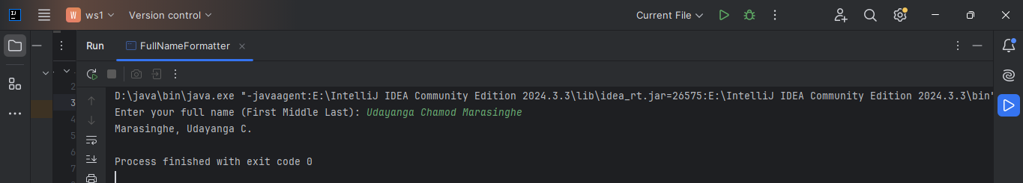

Q12 Code:

|  |
| --- |
| ***package Q12;  import javax.swing.JFrame;  public class WindowDisplay {  public static void main(String[] args) {    JFrame mainWindow = new JFrame("My First Window");    mainWindow.setSize(300, 200);     mainWindow.setLocation(100, 50);    mainWindow.setDefaultCloseOperation(JFrame.EXIT_ON_CLOSE);     mainWindow.setVisible(true);  } }*** |

Output:

